Initialize Repository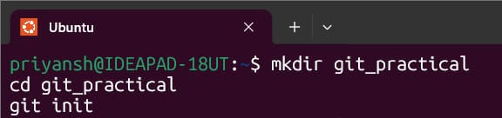
Create File
Add and Commit
Check Status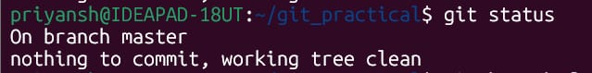
Create branch and modify file in branch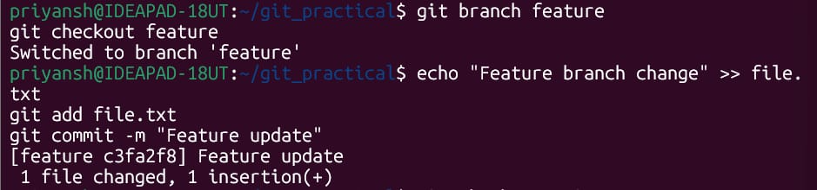
Get back to master mode
Modify File Again (in master)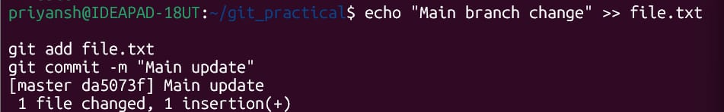
Merge Branch – to witness conflict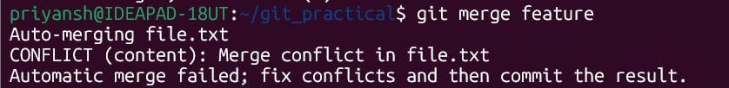
Fix the File.txt file and commit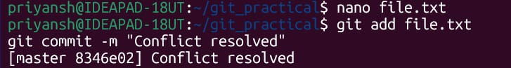
File.txt – original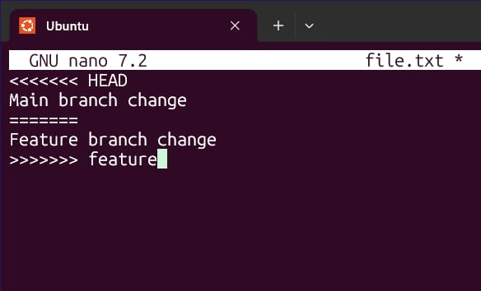
File.txt- edited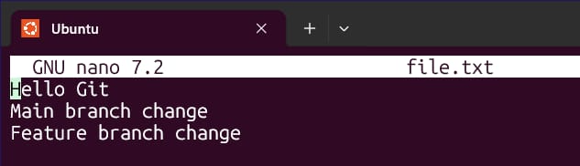

NOTE: Confirm your identity by entering your Username and Email Address of GitHub

